# RISP Career Basics ML 089

Predicting Compressive Strength Of Concrete Using IBM

Watson AutoAl Experiment

submitted by:

1. RAHUL RAIKAR (email: rraikar14@gmail.com)

Contents

1. INTRODUCTION
   1. Overview
   2. Purpose
2. LITERATURE SURVEY
   1. Existing problem
   2. Proposed solution
3. THEORITICAL ANALYSIS
   1. Block diagram
   2. Hardware / Software designing
4. EXPERIMENTAL INVESTIGATIONS
5. FLOWCHART
6. RESULT
7. ADVANTAGES & DISADVANTAGES
8. APPLICATIONS
9. CONCLUSION
10. FUTURE SCOPE

1 1 BIBILOGRAPHY

APPENDIX

A. Source code

1 .INTRODUCTION

1.1 Overview

Compressive strength of concrete is a major problem in civil engineering as compressive strength of concrete is tested by 28 day cylinder test results. Concrete is a great versatile material used in construction due to its good compressive strength, durability and low cost. Concrete great availability and low cost making it widely used in construction work therefore it is highly recommended to check the compressive strength of concrete one has to wait for 28 days test results to ensure quality control of processes due to which it is very time consuming and leads civil engineering industry require more time for the completion of project. In this modern era where human resources are way above high to satisfy any needs implemented advanced machine learning techniques which progressively simulate the characteristic of concrete materials and thus proposed an important research area through which strength of concrete can be determined by early age results.

In this model we use suitable machine learning algorithms to predict result and minimize errors through various metric evaluation techniques like mean square error(MSE), mean absolute error(MAE), root- mean-square error(RMSE) etc.

It mainly uses two algo random forest and gradient booster to enhance accuracy of model.

1.2 Purpose

Purpose of predicting compressive strength of concrete is to save 28 days test results time that will be inefficient for both purchaser as well as constructors. Machine learning techniques predict 28 days results in just seconds by analyzing previous data or results. It allows constructors to understand weakness of concrete material and based on that initiate destruction or construction process. In this time of competitive environment no corporate construction can bear to lose tender due to incompletion of projects on required time because of just one parameter that is ensuring quality of concrete. This model not only benefits purchaser but stakeholders also.

We focused on evaluating and analyzing performance of set of tree using ML techniques and algo for predicting compressive strength.

# 2.LlTERATURE SURVEY

2.1 Existing Problem

Determining accurate concrete strength is a major civil engineering problem. Test results of 28-day concrete cylinder represent the characteristic strength of the concrete that has been prepared and cast to form the concrete work. It is important to wait 28 days to ensure the quality control of the process, although it is very time-consuming. There are several ancient methods to evaluate concrete strength like compression test on concrete cores, rebound hammer method, pull-out test method, ultrasonic pulse velocity method ,but none of these methods accurately evaluate concrete strength, provide reliable results as some develop cracks ,damage concrete and some might affected due to concrete cracks. So we have one option to test compression strength of concrete without even really testing on concrete that is mach i ne learning techniques which analyze previous data to predict compression strength.

2.2 Proposed Solution

An ability to predict the compressive strength of concrete early allows constructors to quickly understand the concrete's probable weaknesses and make a decision to manage a destruction process or continue with construction. Further, to the benefit of both user (and purchaser) and producer, reliably and rapidly predicting the results of a 28-day test would benefit all stakeholders as opposed to waiting the full, conventional, 28 days.

We are building a Machine Learning model to predict the compressive strength of concrete using IBM Watson AutoAl Machine Learning Service.

## 3.Theoritical Analysis

IBM cloud computing is a set of cloud computing services for business offered by the information technology company IBM. IBM Cloud includes infrastructure as a service (laaS), software as a service (SaaS) and platform as a service (PaaS) offered through public, private and hybrid cloud delivery models, in addition to the components that make up those clouds.

3.1 Block Diagram

IBM offers three hardware platforms for cloud computing. These platforms offer built-in support for virtualization. For virtualization IBM offers IBM Websphere applicaon infrastructure that supports programming models and open standards for virtualization.

The management layer of the IBM cloud framework includes IBM Tivoli middleware. Management tools provide capabilities to regulate images with automated provisioning and de-provisioning, monitor operations and meter usage while tracking costs and allocating billing. The last layer of the framework provides integrated workload tools. Workloads for cloud computing are services or instances of code that can be executed to meet specific business needs. IBM offers tools for cloud based collaboration, development and test, application development, analytics, business-to-business integration, and security. IBM Watson Studio helps data scientists and analysts prepare data and build models at scale across any cloud. With its open, flexible multicloud architecture, Watson Studio provides capabilities that empower businesses to simplify enterprise data science and Ali such as:

* Automate Al lifecycle management with AutoAl
* Visually prepare and build models with IBM SPSS Modeler
* Build models using images with IBM Watson Visual Recognition and texts with IBM Watson Natural Language Classifier
* Deploy and run models through one-click integration with IBM Watson Machine Learning
* Manage and monitor models through integration with IBM Watson OpenScale

IBM SmartCloud delivered by public, private or hybrid models

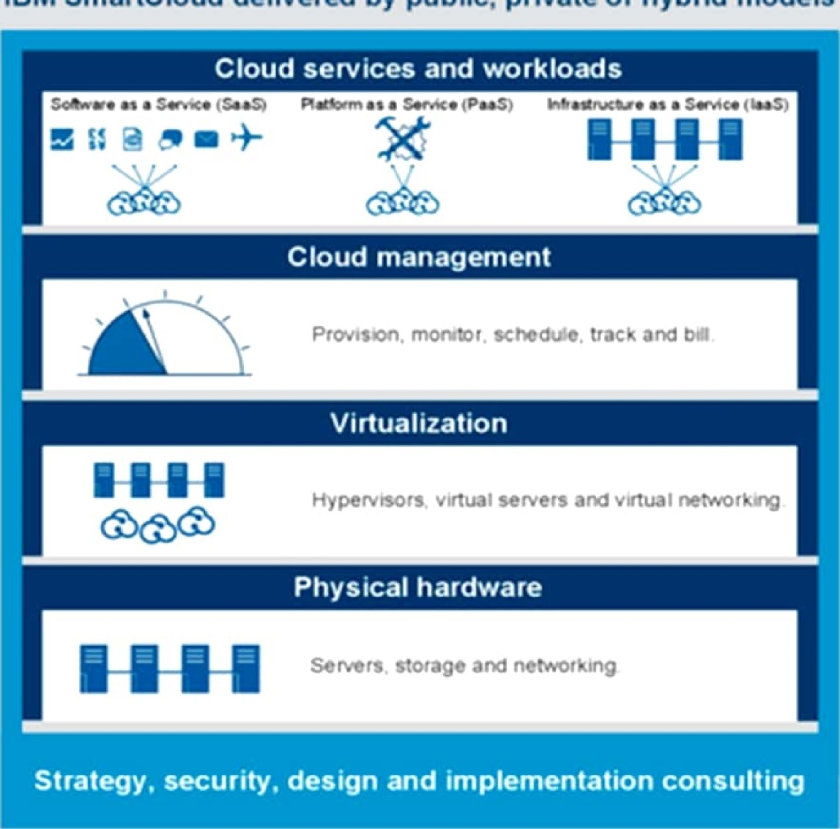

3.2 Hardware/Software designing

Building model with Watson Studio Auto Al on IBM cloud platform not only provide Machine learning, Artificial Intelligence services but also provide many services to build different-different models on IBM cloud. IBM cloud also provides virtual systems or hardware to run our model. IBM cloud automatically selects best fit machine learning algorithm for provided dataset watson studio does so by applying pipelining to the provided dataset and test dataset with different machine learning and give best fit algorithm result which having minimum Root Mean Square error(RMSE). Following image shows the working of above:

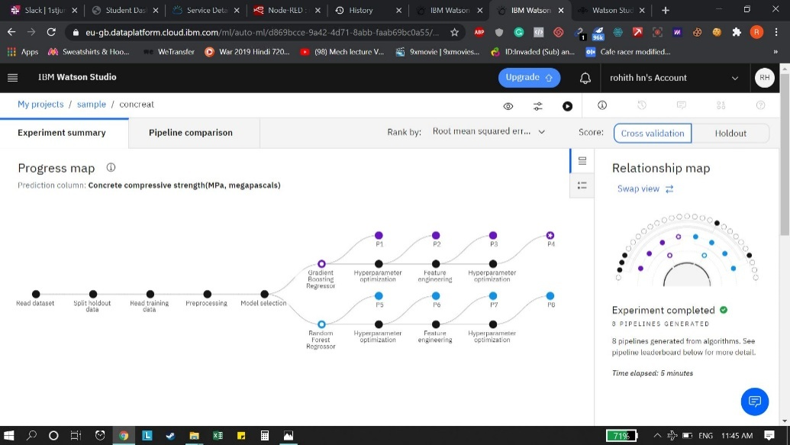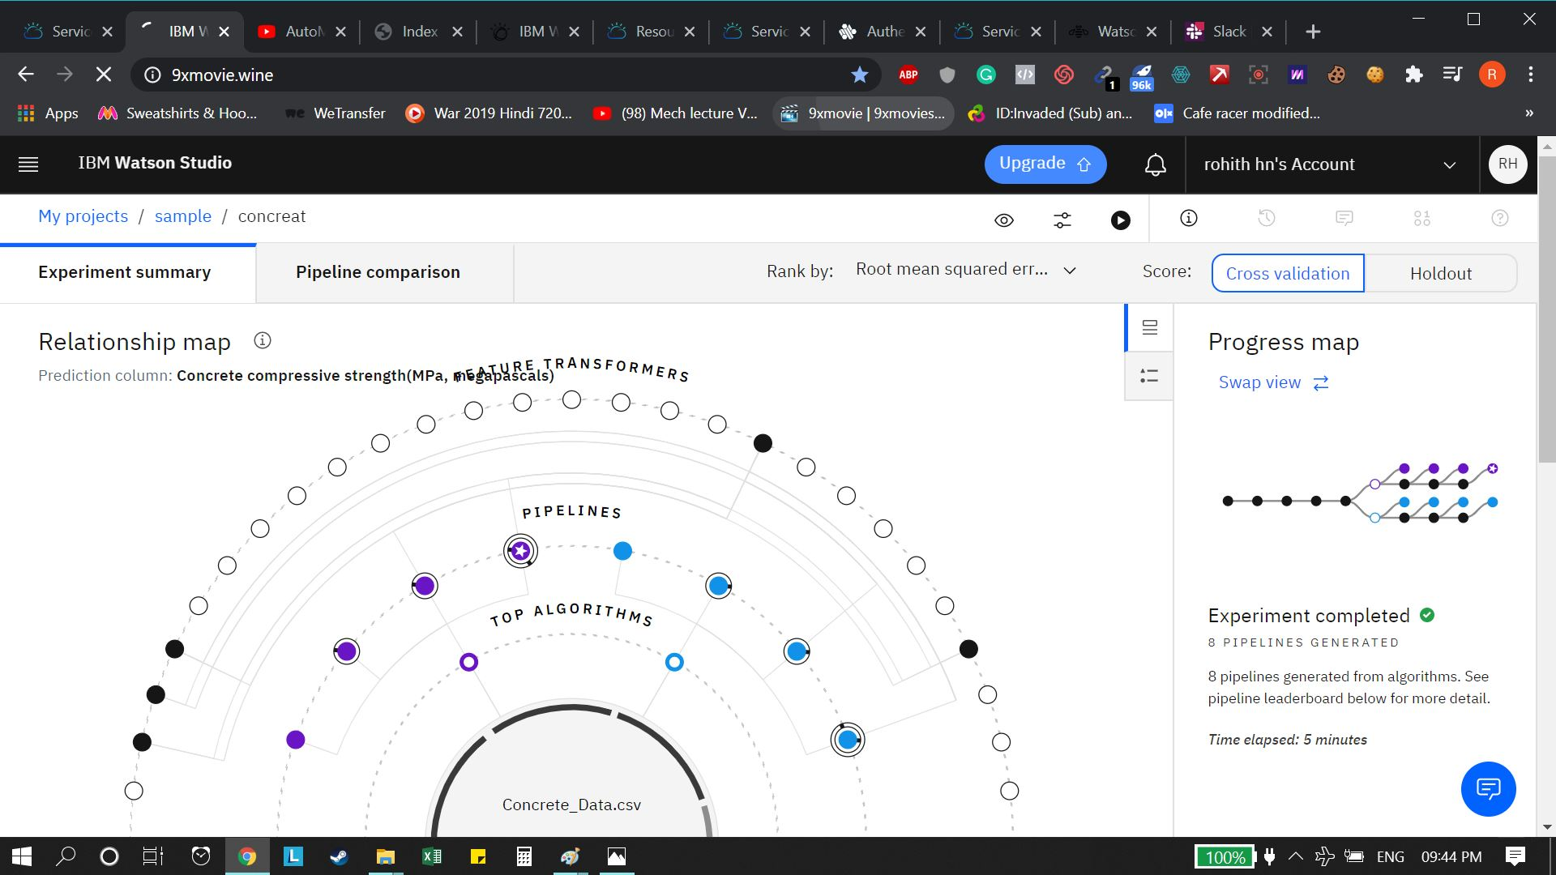



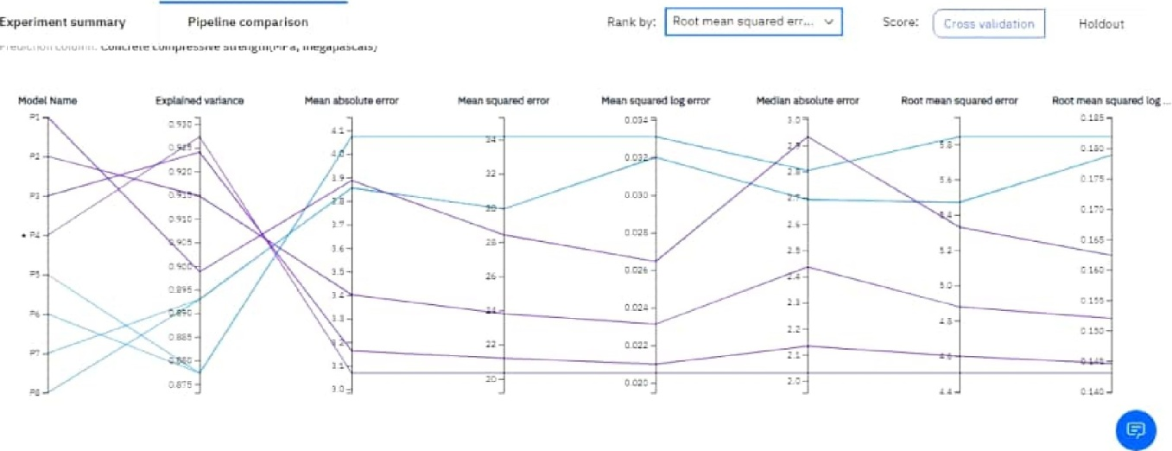

pejpeline comp.aLl.S.Qn

 Pipe!ins Gradient Boosting4.502

1. Pipeline 3 Gradvent Boosting4.598 HPO.I
2. Pipeline 2 Gradient Boost Regresscr DOC-o:ll
3. Pipeline i Gradient Boosting5.330 None
4. Pipeline 7 Agndc,rn Forevt
5. Random

5 7 5 %ndom ForestNone

PipæiRandom Forest5.ga3

Pipeline leaderboard

## 4. EXPERIMENTAL INVESTIGATIONS

IBM cloud not only provide implementation of Machine Learning and Artificial

Intelligence projects for creation of web app but also provides testing of model after saving and creating best fit algo for model , we test our model on IBM watson studio

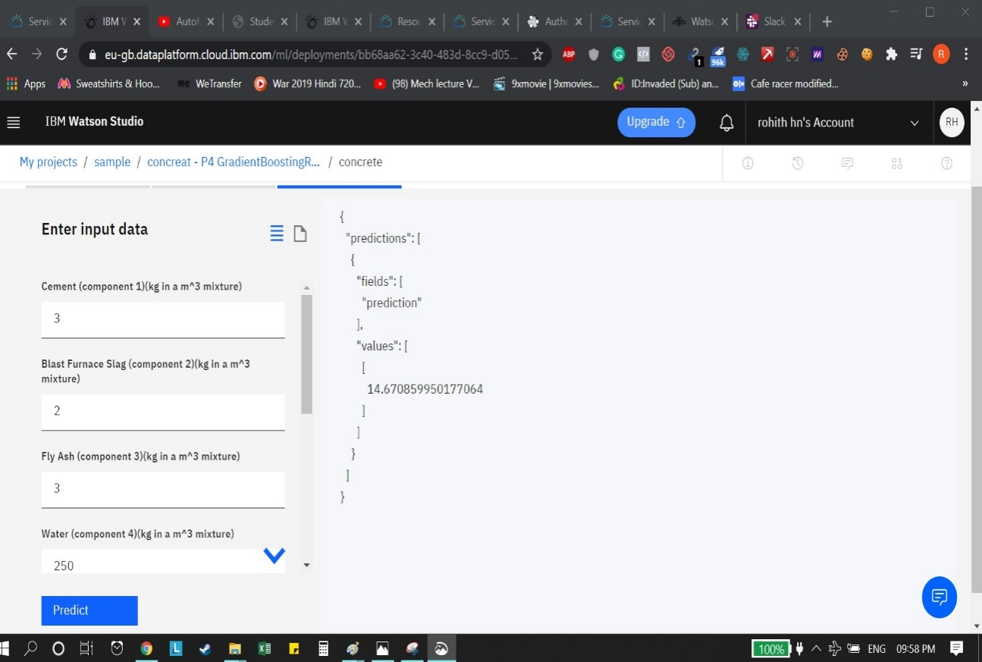

From above output it is clear that our model can predict compressive strength of concrete after giving particular features.

### 5.FLOWCHART

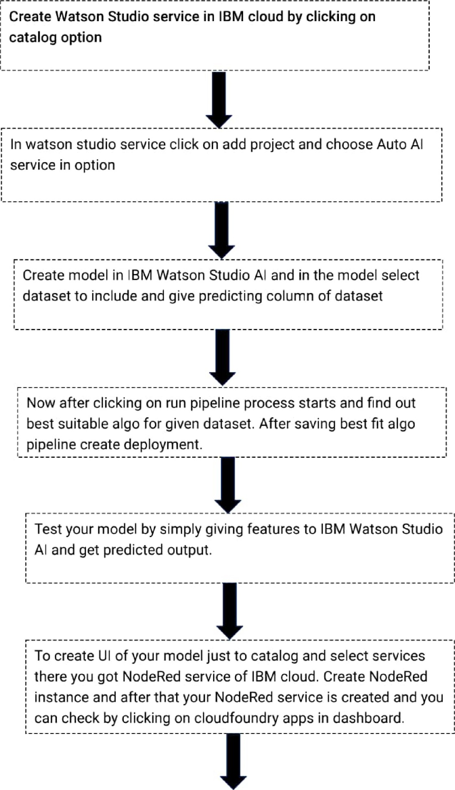

Import JSON file by doing changes according to your model.

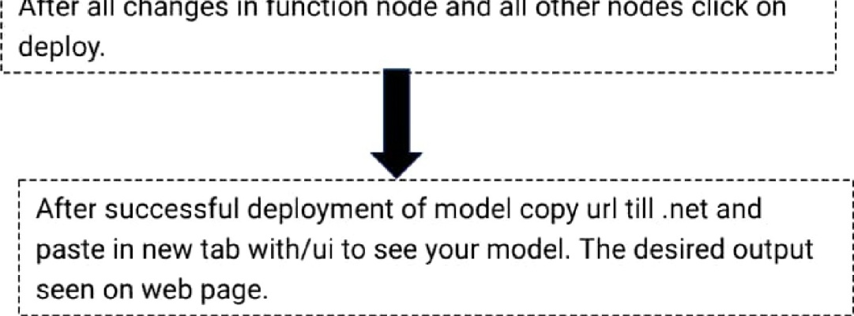

After all changes in function node and all other nodes click on

# 6.RESULTS

By using IBM cloud Watson Studio Al service we create our machine learning by giving dataset and with the help of NodeRed service of IBM cloud we are able to turn our machine learning model a beautiful web app

fig. Screenshot of web ui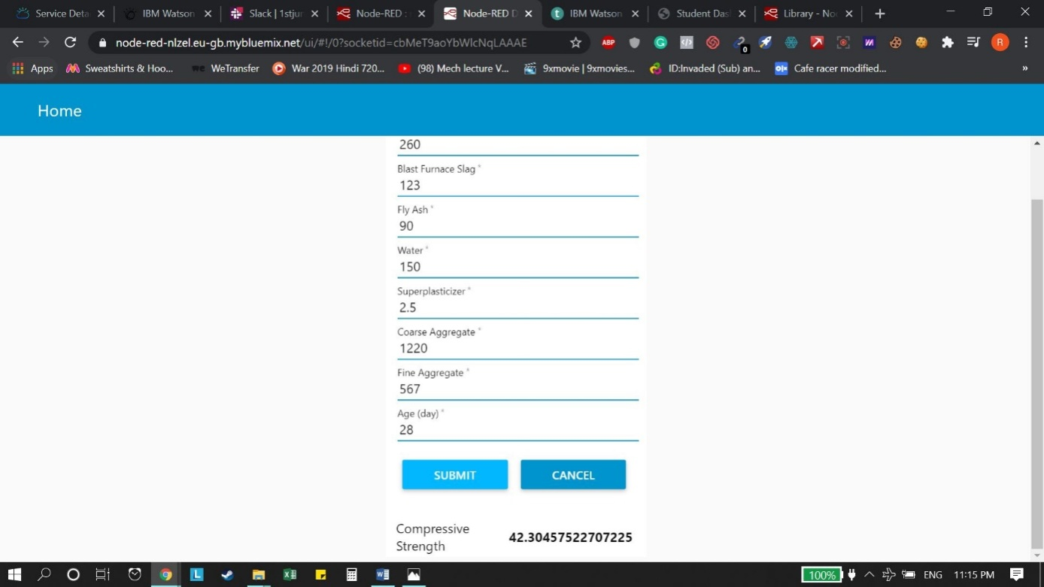

## 7.ADVANTAGES AND DISADVANTAGES

Advantages:

* Saves a lot of time
* By computation solves problem rather than testing it manually.
* Don't require manforce to determine strength of concrete.
* Beneficial for constructors and stakeholders.
* Constructors determine weakness of concrete materials easily.
* Don't need any equipment to test concrete strength.

Disadvantages:

* Results are not very effective.
* Due to prediction by Al system actual results might vary in different circumstances.
* Manually conducted real test produce much more effective and accurate results as compare to prediction done by Al system.

# 8.APPLlCATlONS

1. Material strength prediction.
2. Determine weightage of mixture of construction ingredients.
3. Construction work renovation prediction.

# 9.ConcIusion

The main purpose of the application is to build machine learning model to predict compressive strength of concrete using IBM Watson Auto Al Machine Learning service. The model is deployed on IBM cloud to get scoring end point which can be used as API in mobile app or web app building. We are deploying web app using nodered service.

The model prediction is then showcased on User Interface.

Construction companies use this model to predict strength of concrete and also helps in building higher strength concrete by determining weaknesses of concrete and check materials that are highly correlated with concrete material. Concrete can have cracks or void or irregular surface inside which decreases its age therefore machine learning techniques helps in determining those parameters so that any civil engineering deployment dont need repair before their age of destruction. Machine learning techniques not only solve real world problems but also effective in solving our day-to day tasks to make our life more better. This model not only saves time but beneficial for whole construction corporations.

# 10.FUTURE SCOPE

Construction companies need to know material strength before building any civil applications as the material used in that should strong enough to bind and hold compreesive strength and tension strength. Material strength prediction used by construction companies to determine strength without involving so much civil calculations just predict strength using early data. Construction companies can determine the renovation period at the time of construction using machine learning techniques. Maintenance period of construction sites can be decreased by determining correct mixture proportion of construction materials and their compression limit until they break.

## 1 1 .Bibliography_

Compressive strength prediction using ML



ine-learning-4a531 b3c43f3

# APPENDIX

SOURCE CODE:

[{"id":"d9a2f9b.e35b808","type":"ui_form","z":"53d58234.cf2afc","name":"","label":"","group":"5f5a2193.636f3","order":1,"width":0,"height":0,"options":[{"label":"Cement","value":"cmt","type":"number","required":true,"rows":null},{"label":"Blast Furnace Slag","value":"bfs","type":"number","required":true,"rows":null},{"label":"Fly Ash","value":"fah","type":"number","required":true,"rows":null},{"label":"Water","value":"wtr","type":"number","required":true,"rows":null},{"label":"Superplasticizer","value":"sup","type":"number","required":true,"rows":null},{"label":"Coarse Aggregate ","value":"coa","type":"number","required":true,"rows":null},{"label":"Fine Aggregate ","value":"fag","type":"number","required":true,"rows":null},{"label":"Age (day)","value":"age","type":"number","required":true,"rows":null}],"formValue":{"cmt":"","bfs":"","fah":"","wtr":"","sup":"","coa":"","fag":"","age":""},"payload":"","submit":"submit","cancel":"cancel","topic":"","x":90,"y":420,"wires":[["61ccc4f7.58548c"]]},{"id":"5f5a2193.636f3","type":"ui_group","z":"","name":"Compressive Strength of Concrete","tab":"45cbf893.42eec8","order":1,"disp":true,"width":"6","collapse":false},{"id":"45cbf893.42eec8","type":"ui_tab","z":"","name":"Home","icon":"dashboard","disabled":false,"hidden":false}]